Exploring the Relationship Between
Childcare Costs and Workforce Participation
in the United States
Final Report

Vijay Sharma
Bellevue University
DSC 680: Applied Data Science
Instructor: Xu Ashton
August 20th 2026

Abstract
This study examines whether childcare affordability is associated with workforce participation across U.S. counties and states. The National Database of Childcare Prices was analyzed for 2008–2018. After requiring complete values for center-based infant care, income, labor-force participation, unemployment, and population, 23,593 county-year observations remained. Weekly infant prices were annualized and divided by inflation-adjusted median household income to create an affordability-burden measure. Descriptive analysis, correlations, regional comparisons, robust ordinary least squares regression, and a holdout predictive model were used. Average annual infant-care cost increased 28.8%, from $8,694 to $11,195. The uncontrolled county-level correlation between burden and participation was small and negative (r = -0.041), while the adjusted regression coefficient was not statistically significant (b = 0.015, p = 0.470). Regional burden differences were significant (p = 0.027). Results suggest that childcare affordability is a meaningful household pressure and varies geographically, but this observational dataset does not establish a direct causal reduction in workforce participation.

Keywords: childcare affordability, labor-force participation, county-level analysis, regression, public policy

Introduction
Childcare is both a household expense and an economic input that enables parents and caregivers to participate in paid employment. When care consumes a large share of income, families may change work hours, rely on informal care, move between care settings, or leave employment. At the same time, high childcare prices may occur in prosperous labor markets where wages and workforce participation are also high. This creates an empirical challenge: price alone does not represent affordability, and a simple correlation cannot establish causation.

The project proposed in Milestone 2 asked how childcare costs influence workforce participation across U.S. states, which states experience the greatest burden, how cost relates to income, whether higher costs correspond with lower participation, whether regions differ, and how costs changed over time. The present analysis answers those questions using measures already contained in the National Database of Childcare Prices.

Problem Statement and Purpose
Families, employers, and policymakers need evidence that distinguishes childcare price from childcare affordability. A high-dollar state may also have high household income, while a moderately priced state may impose a larger burden on lower-income households. The purpose of this study is to quantify price, burden, workforce participation, geographic variation, and trends, while avoiding causal claims that the data cannot support.

Research Questions
- How do childcare costs influence workforce participation rates across U.S. states?
- Which states experience the highest childcare affordability burden?
- What relationship exists between childcare costs and median household income?
- Do higher childcare costs correspond with lower labor-force participation rates?
- Are there regional differences in childcare affordability?
- How have childcare costs changed over time?

Data and Methodology

Dataset
The National Database of Childcare Prices file contains 34,567 county-year records, 3,144 counties, 51 state or district codes, and annual observations from 2008 through 2018. Variables used included MCInfant, MHI_2018, FLFPR_20to64_Under6, FLFPR_20to64, UNR_20to64, TotalPop, state, county, and year. Childcare-price availability reduced the complete-case analytical sample to 23,593 county-year observations.

Operational Definitions
Construct | Operational definition
Annual infant childcare cost | MCInfant weekly center-based infant price × 52.
Affordability burden | Annual infant childcare cost ÷ inflation-adjusted median household income × 100.
Workforce participation | Female labor-force participation, ages 20–64, in households with a child under age 6.
State-year estimate | County values aggregated using total population as the weight.
Region | Northeast, Midwest, South, or West using a four-region state grouping.

Analytical Procedure
- Validated identifiers, study years, ranges, and missing values.
- Created annual cost and affordability-burden measures.
- Calculated county-year and population-weighted state-year correlations.
- Compared 2018 regional burdens with one-way ANOVA.
- Estimated robust OLS with burden, unemployment, log income, year indicators, and region indicators.
- Evaluated a linear predictive model with an 80/20 holdout split.

Results

Descriptive Trends
Average state-level annual center-based infant care cost rose from $8,694 in 2008 to $11,195 in 2018, a 28.8% increase and approximately 2.6% compound annual growth. Mean burden increased from 14.3% to 17.8%.
Figure 1
Average Annual Center-Based Infant Care Cost
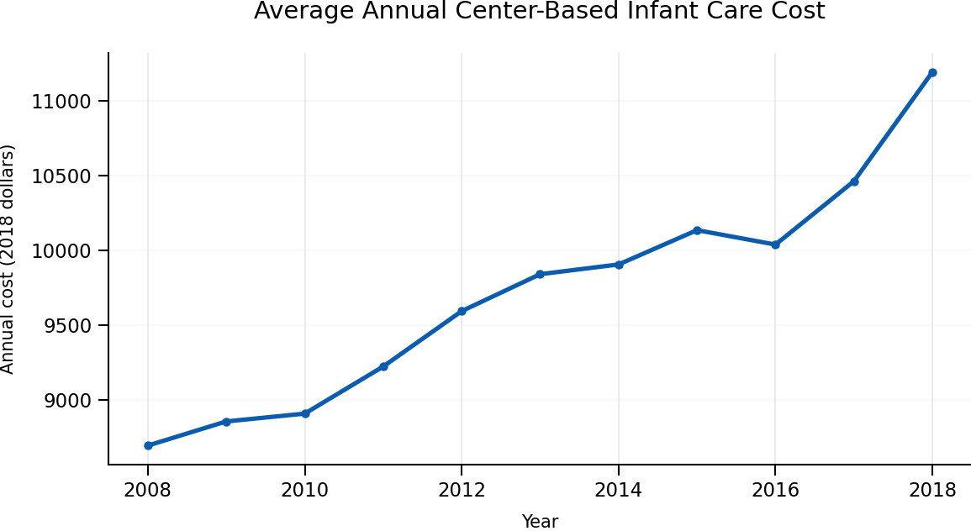
Note. State-year population-weighted estimates from the National Database of Childcare Prices; costs use 2018-dollar income context.

States With the Highest Burden
Among states with complete 2018 estimates, New York and Massachusetts had the highest population-weighted infant childcare burdens, followed by California. Rankings reflect annual center-based infant cost as a percentage of median household income and should not be interpreted as household-specific budgets.

State | Annual cost | Burden | Participation
New York | $17,382 | 27.0% | 72.4%
Massachusetts | $19,703 | 25.3% | 77.3%
California | $17,025 | 23.8% | 67.2%
Hawaii | $18,000 | 21.7% | 64.5%
Minnesota | $15,088 | 21.4% | 80.6%
Wisconsin | $12,549 | 21.3% | 78.9%
Connecticut | $16,291 | 21.1% | 75.3%
Ohio | $11,454 | 21.0% | 75.1%
Washington | $14,926 | 20.8% | 65.1%
Illinois | $13,281 | 20.6% | 73.7%
Figure 2
Highest Infant Childcare Burden by State, 2018
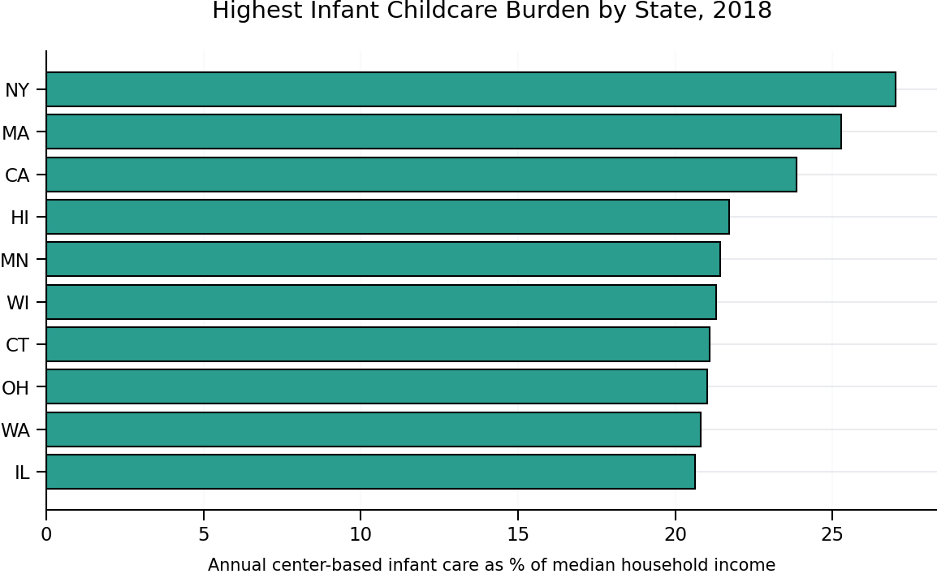
Note. The ranking is limited to 2018 state estimates with complete analytical variables.

Cost, Income, and Participation
Across available state-year observations, annual infant childcare cost and median household income were strongly positively correlated (r = 0.753, p < .001). This indicates that high-price locations also tended to have higher incomes. At the county-year level, affordability burden and workforce participation had a very small negative correlation (r = -0.041, p < .001). The large sample makes small effects statistically detectable, so practical magnitude is more important than the p value.
Figure 3
Childcare Cost and Household Income, 2018
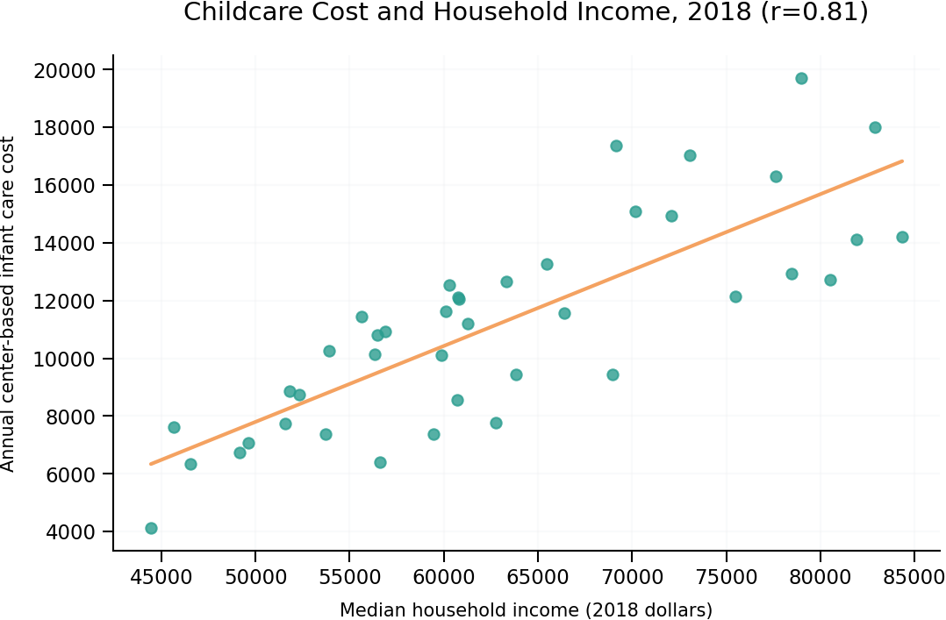
Note. Each point represents a population-weighted state estimate with complete 2018 data.
Figure 4
Affordability Burden and Labor-Force Participation, 2018
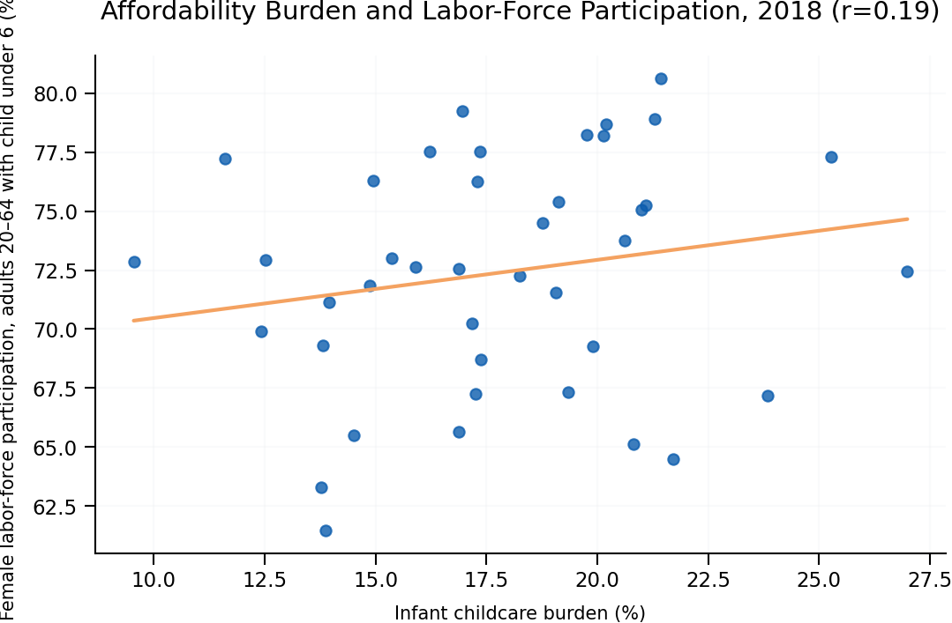
Note. The bivariate state relationship does not control for unemployment, income, year, or region.

Adjusted Regression and Predictive Model
The robust county-year OLS model explained 15.2% of variation in participation. After controlling for unemployment, log income, year, and region, a one-percentage-point increase in burden was associated with a 0.015-point change in participation. The 95% confidence interval ranged from -0.026 to 0.055, and the coefficient was not statistically significant (p = 0.470). Therefore, the adjusted model does not provide evidence that higher burden independently predicts lower participation in this dataset.

The state-year holdout model achieved R² = 0.644 and RMSE = 3.14 percentage points on 78 test observations. This is useful for describing predictive performance, but it is not a causal model and the random split does not fully address repeated observations from the same state.

Regional Differences
The 2018 regional comparison found statistically significant differences in mean burden, F = 3.44, p = 0.027. The Northeast had the highest mean burden (20.4%), while the South had the lowest (15.7%).
Region | Mean burden | Mean annual cost | Mean participation
Midwest | 17.8% | $10,750 | 76.4%
Northeast | 20.4% | $13,890 | 75.8%
South | 15.7% | $8,829 | 71.1%
West | 18.1% | $12,410 | 66.3%
Figure 5
Regional Differences in Infant Childcare Burden, 2018
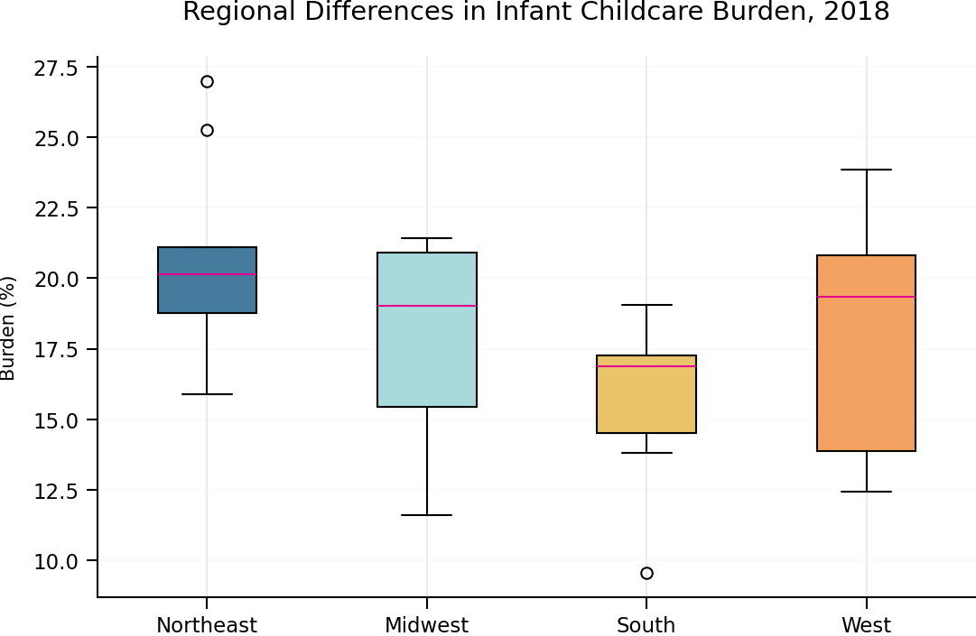
Note. Boxes summarize the distribution of available state estimates within each region.

Discussion
The analysis yields three central findings. First, the cost of center-based infant care rose substantially over the study period, and the share of income represented by that cost also increased. Second, childcare price is closely tied to local income, which makes burden a more informative measure than price alone. Third, after adjustment for income, unemployment, year, and region, burden was not a statistically significant independent predictor of workforce participation. This finding does not mean childcare affordability is unimportant. It means the aggregate observational variables available here do not isolate a direct causal effect.

The positive or near-zero state-level relationships should be interpreted as evidence of confounding rather than evidence that expensive childcare improves participation. High-cost states may have stronger labor markets, higher wages, greater demand for formal care, different subsidy structures, or different demographic composition. Individual household decisions may also be hidden by county and state aggregation.

Recommendations
- Target affordability initiatives to high-burden locations rather than relying on price alone.
- Pair childcare assistance with workforce and employer policies such as predictable scheduling and dependent-care benefits.
- Track childcare burden annually using income-adjusted measures and multiple care settings.
- For future research, add household-level parental employment, family composition, subsidy use, urbanicity, and cost-of-living controls.
- Use longitudinal or quasi-experimental designs before making causal policy claims.

Ethical Considerations and Limitations
The dataset is aggregated and does not contain personally identifiable information. Nevertheless, responsible interpretation requires attention to ecological fallacy, missing childcare-price observations, imputed values, unequal county population sizes, regional heterogeneity, and the difference between statistical significance and practical significance. The use of a single center-based infant price does not represent every family’s care arrangement. State aggregations cover only states with complete observations for a given year, including 41 states or districts in the 2018 analytical comparison. Results are associations, not proof of causation.

Conclusion
Childcare affordability varied considerably across the United States and worsened on average from 2008 to 2018. High-price states frequently also had higher incomes, but several states still faced burdens exceeding one-fifth of median household income. The adjusted analysis did not identify an independent negative relationship between burden and workforce participation. The strongest evidence from this project concerns rising costs and geographic disparities. Policy and employer responses should therefore focus on affordability and access while future research uses richer household-level and causal designs.

References
U.S. Department of Labor, Women’s Bureau. (2023). National Database of Childcare Prices [Data set].
U.S. Census Bureau. (n.d.). Census regions and divisions of the United States.
Sharma, V. (2026). Exploring the relationship between childcare costs and workforce participation in the United States [Unpublished milestone paper]. Bellevue University.

